

cloud computing PRACTICALs

Name: Saurav Kumar



## Submitted by: Saurav Kumar

## Roll NO.: 20222745

## Semester – VI

## Course – B.Voc (Software development)

## Submitted to: Mrs. Asmita Patel (Guest Faculty, Ramanujan College)

***Differentiate between centralized and decentralized system***

***Code***

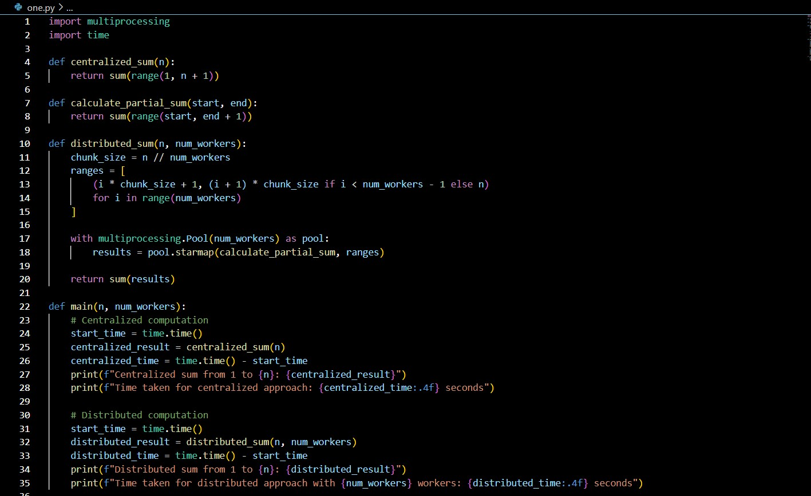

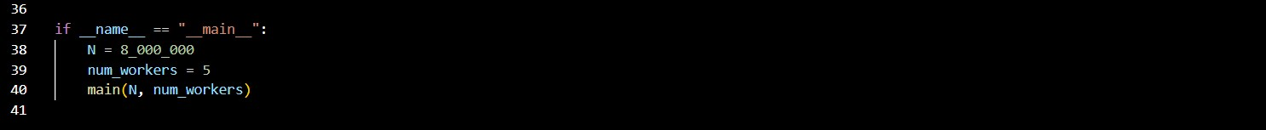

***Output***

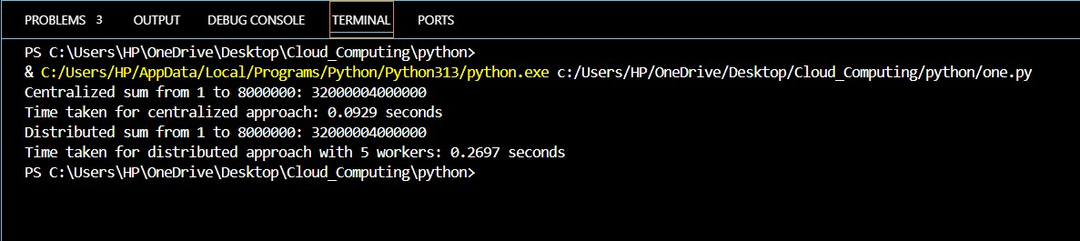

1. ***Launch an EC2 Instance (Ubuntu)***
   1. Create a new EC2 instance using an **Ubuntu AMI**.
   2. Select a **General Purpose instance type**.
   3. Configure key pair, security group, and default network settings.

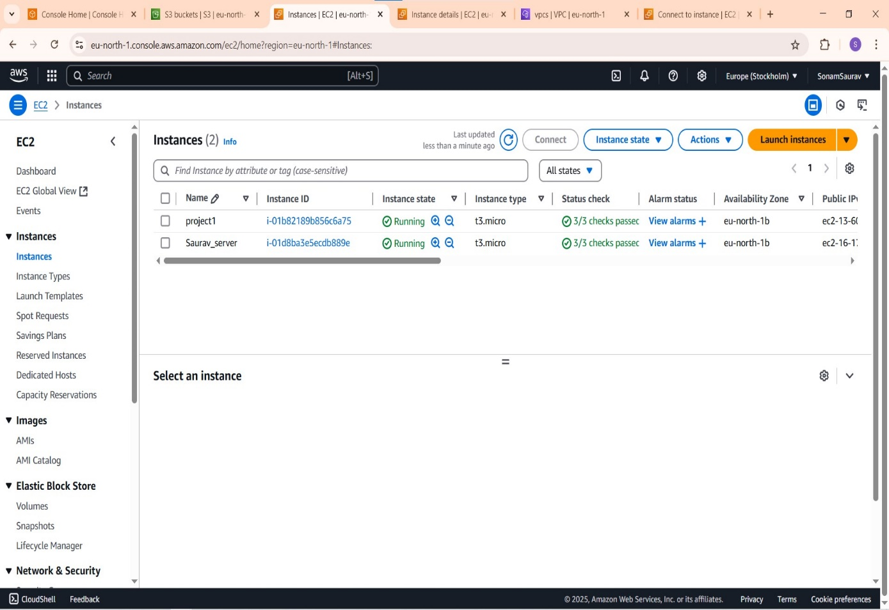***a.***

***b.***

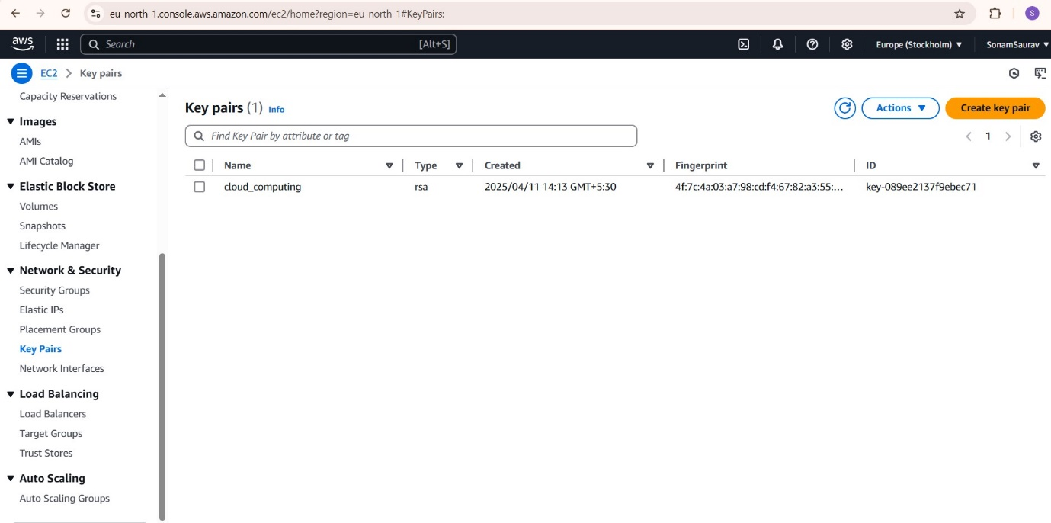

c.

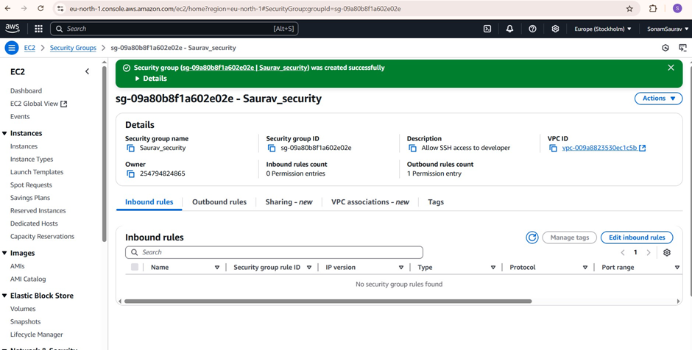

# *Connect to EC2 via SSH and Run Basic Commands*

* 1. Use SSH to connect to EC2 instance from local machine.
  2. Run the following commands:

$cat /etc/os-release and $free -m

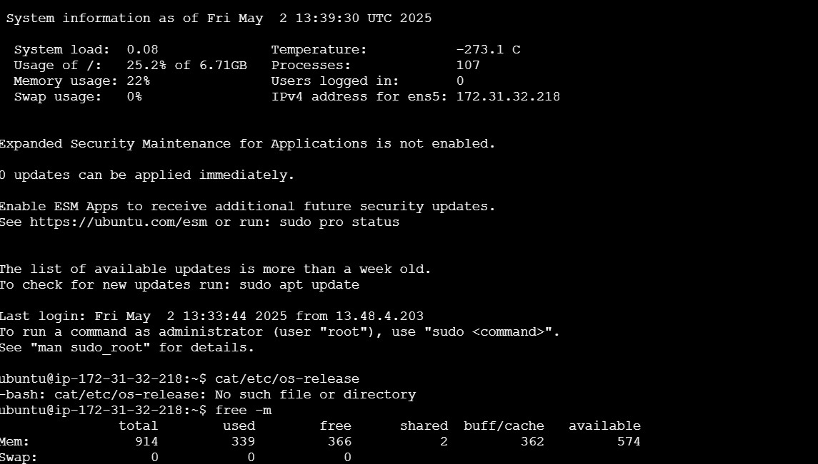

$ lscpu

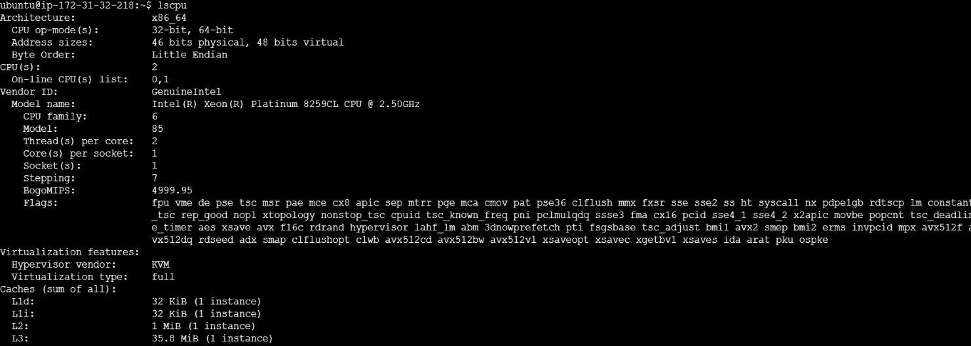

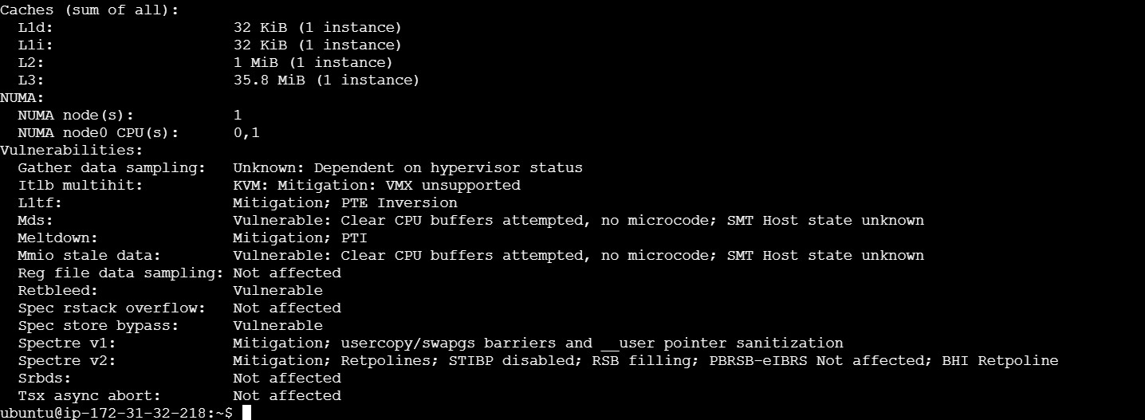

$ df –h and $ ip a and $ uname –r and $ ls –lh and $ chmod

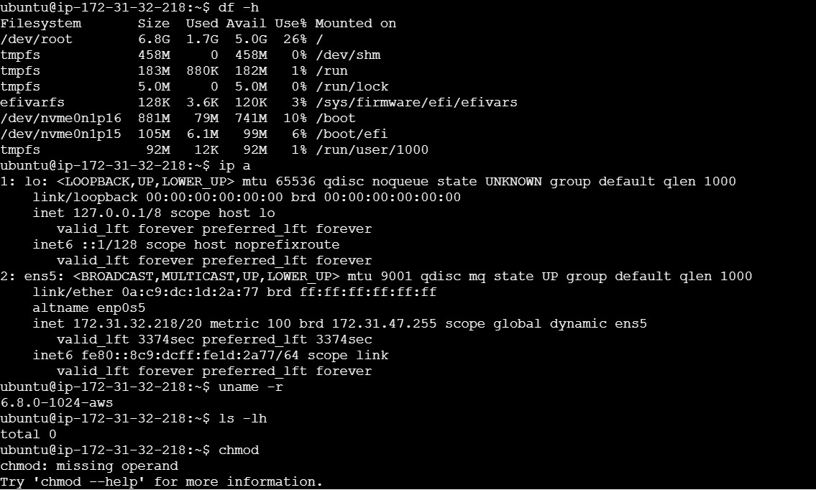

$ls and $ exit



# *Create a VPC with Public and Private Subnets*

* 1. Create a **custom VPC**.
  2. Add one **public subnet** and one **private subnet** within the VPC.

a.

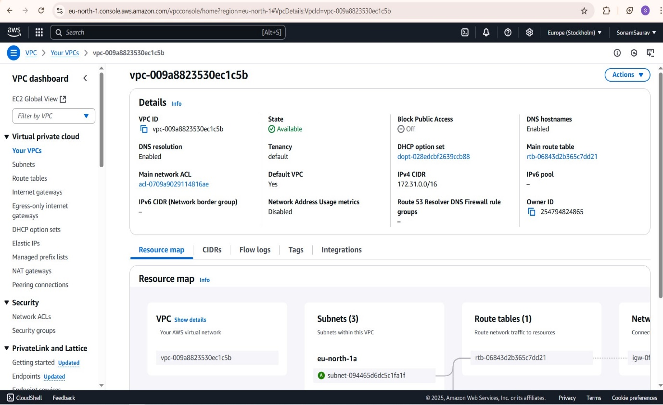

b.

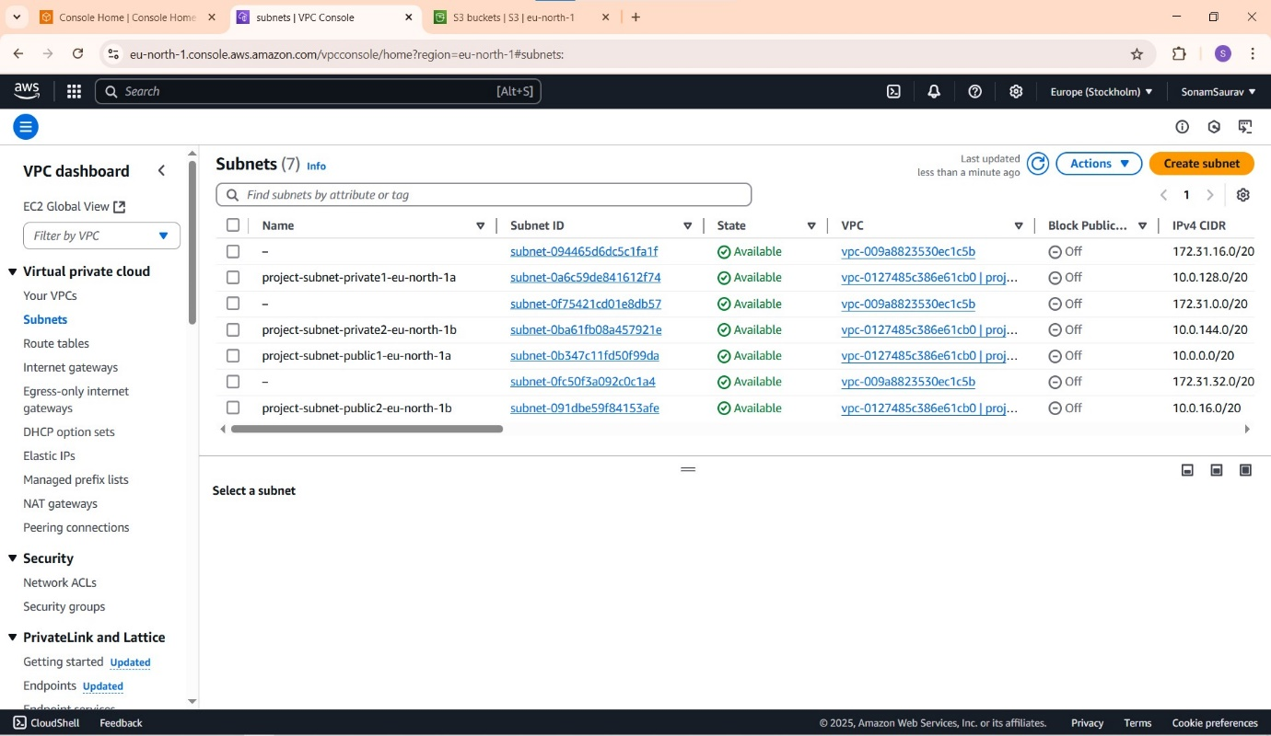

1. ***Create and Attach an Internet Gateway***
   1. Create an **Internet Gateway (IGW)**.
   2. Attach the IGW to your VPC to allow internet access for public subnets.

**a.**

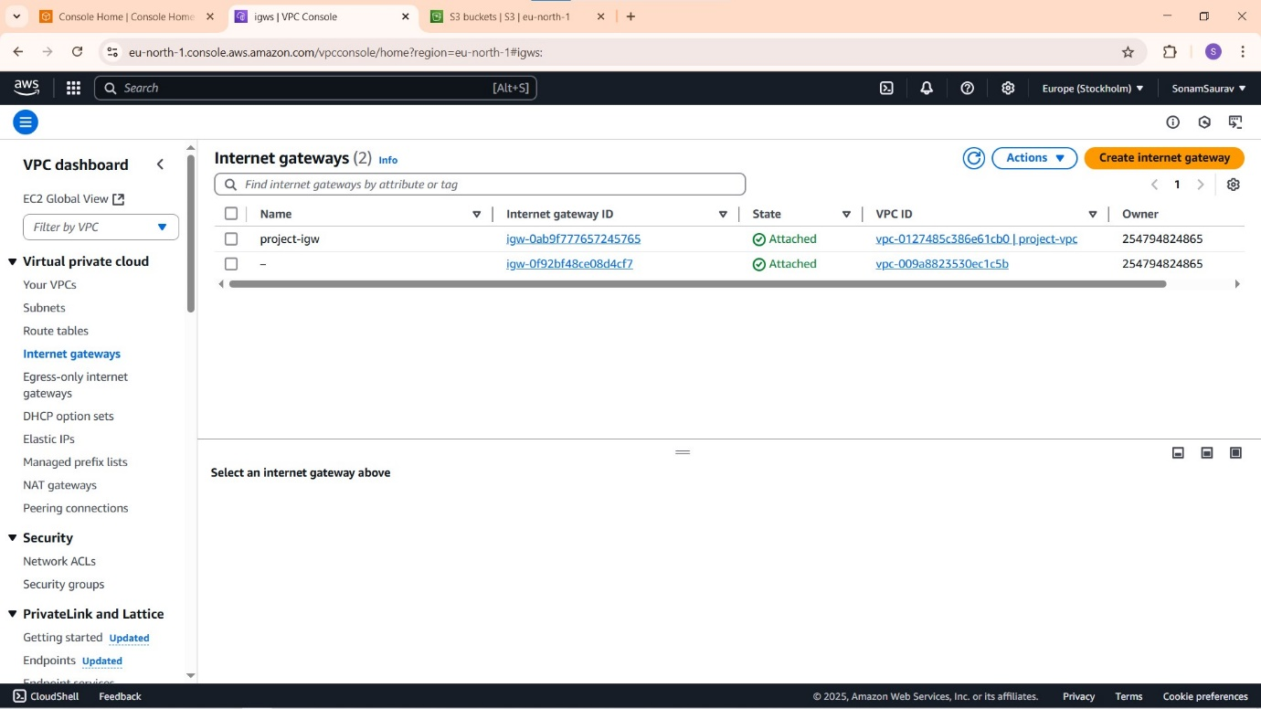

***b.***

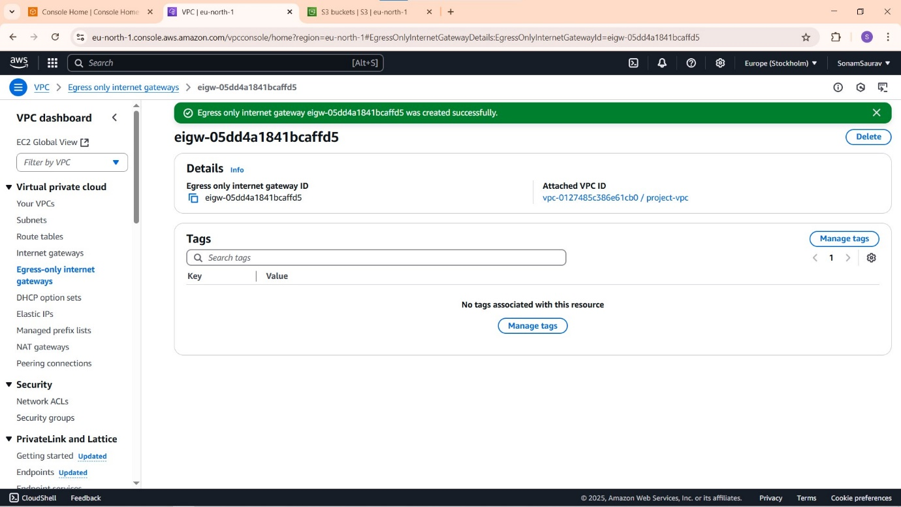

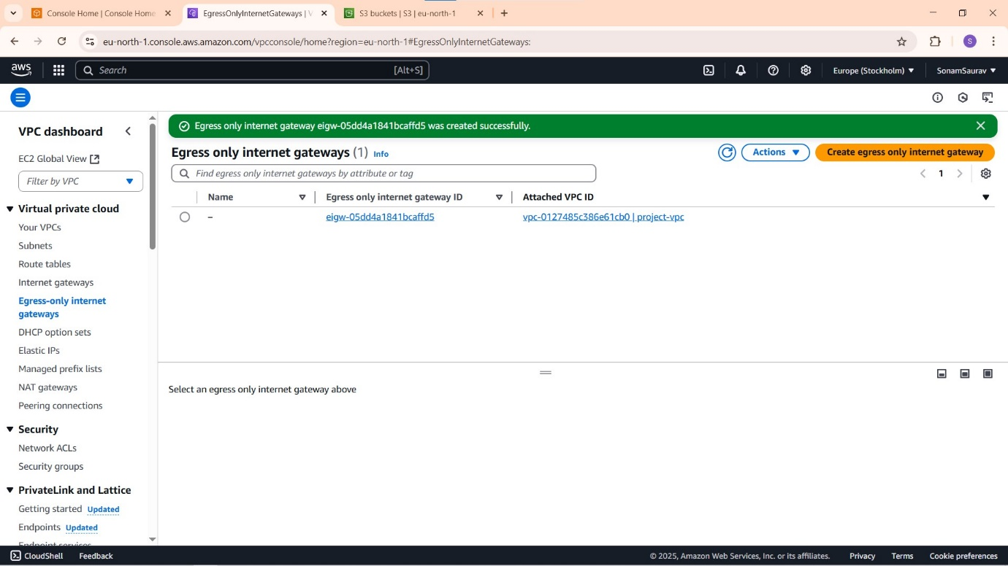

# *Create and Configure Route Tables*

* 1. Create two route tables:
     + A **public route table** with a route to 0.0.0.0/0 via the IGW.
     + A **private route table** with no internet route.
  2. Associate each route table with the appropriate subnet.

**a.**

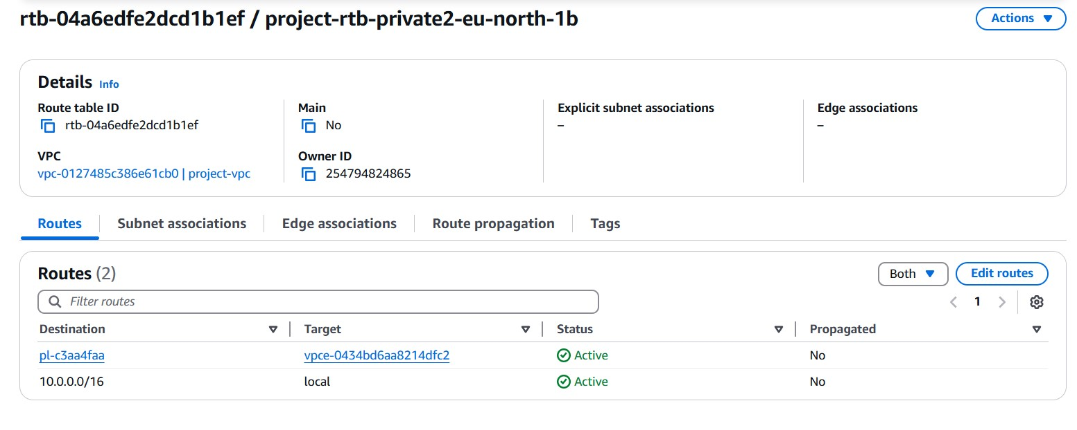

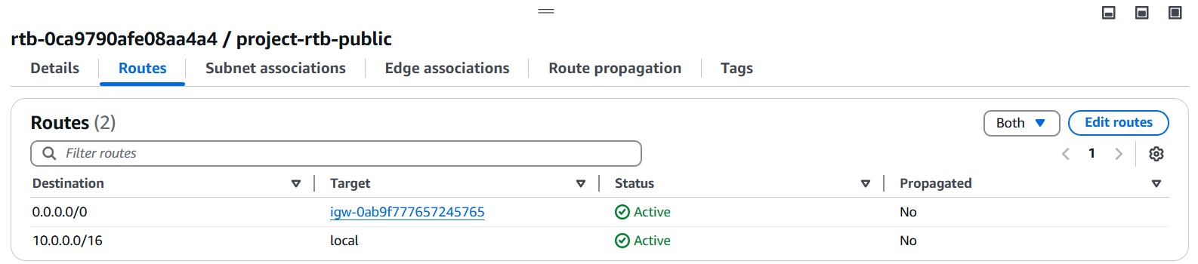

**b.**

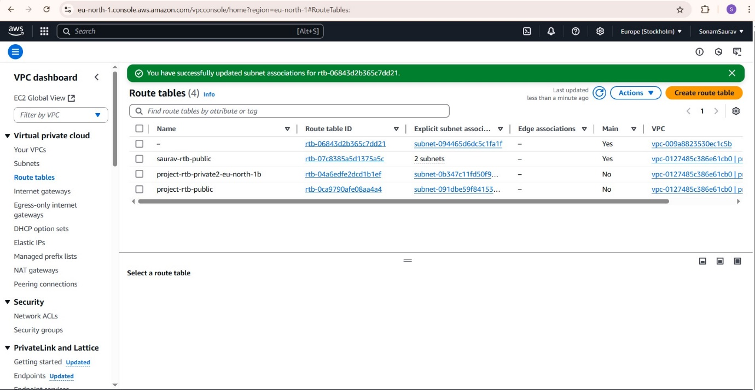

1. ***Launch EC2 Instances in Both Subnets***
   1. Launch one EC2 instance in the **public subnet** and another in the **private subnet**.
   2. Ensure the public instance has a public IP for external access.

**public subnet**

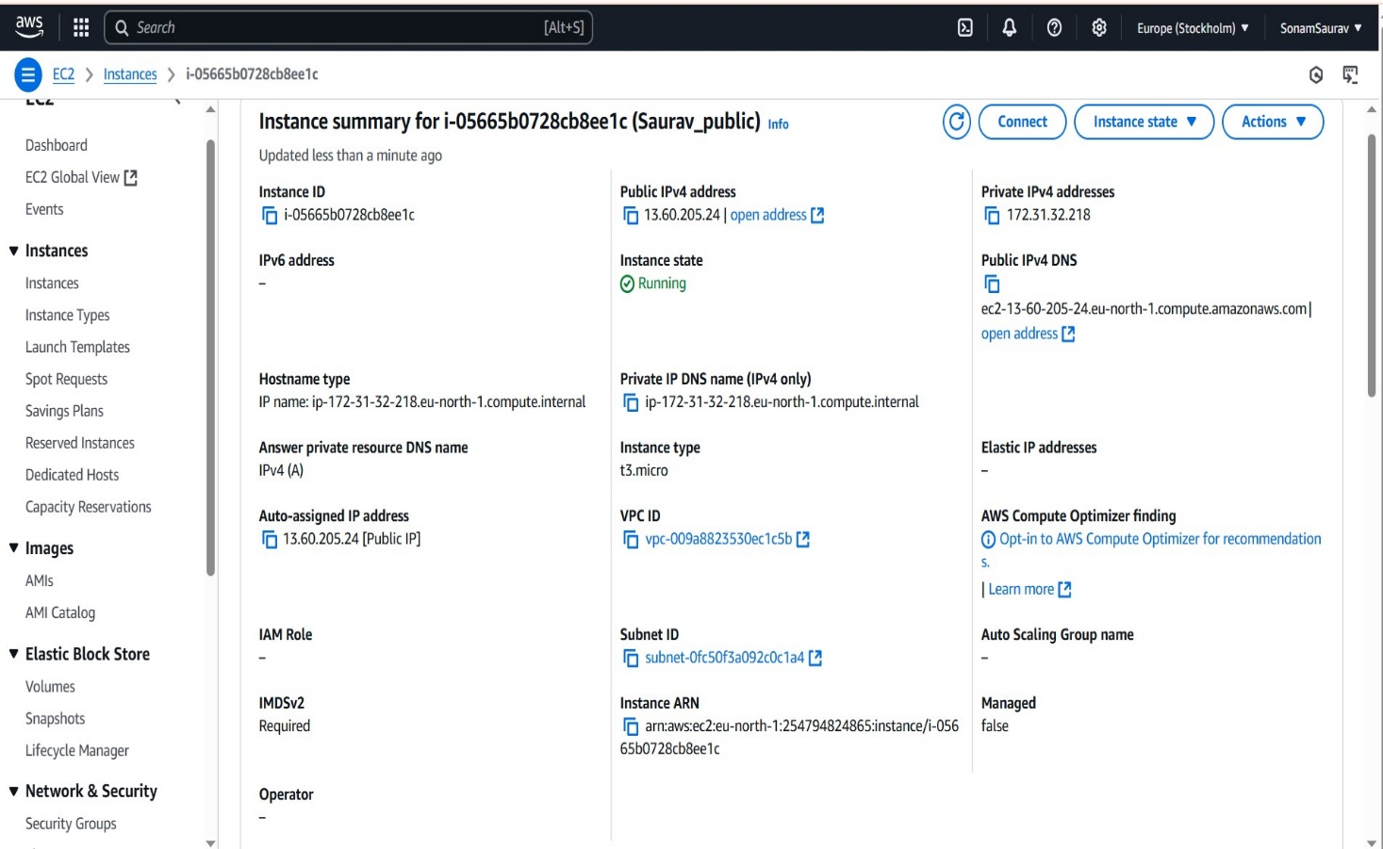

**Private subnet**

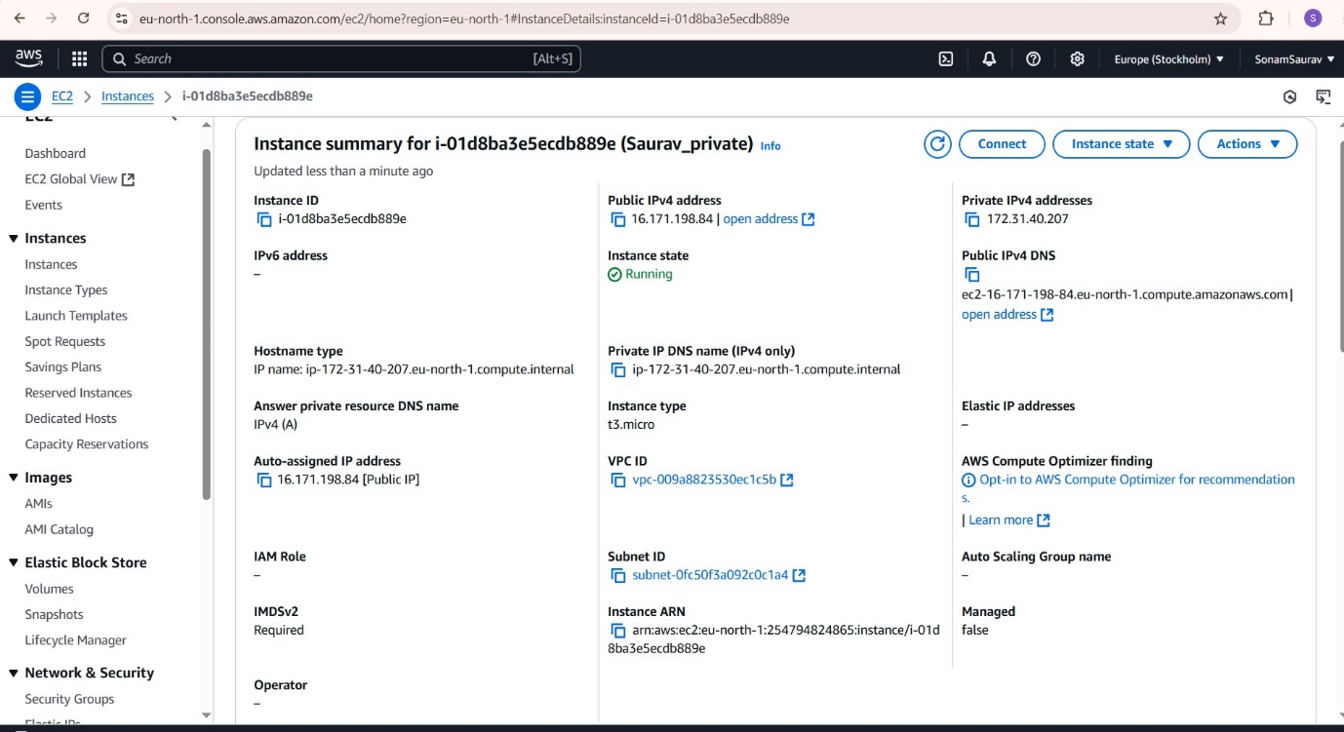

1. ***Install NGINX and Deploy a Sample Application***
   1. SSH into the public EC2 instance.
   2. Install **NGINX** and deploy a basic HTML page: “Welcome to AWS”

***a.***

***Install nginx***

***$sudo –i and $apt-get update and $nginx –t***

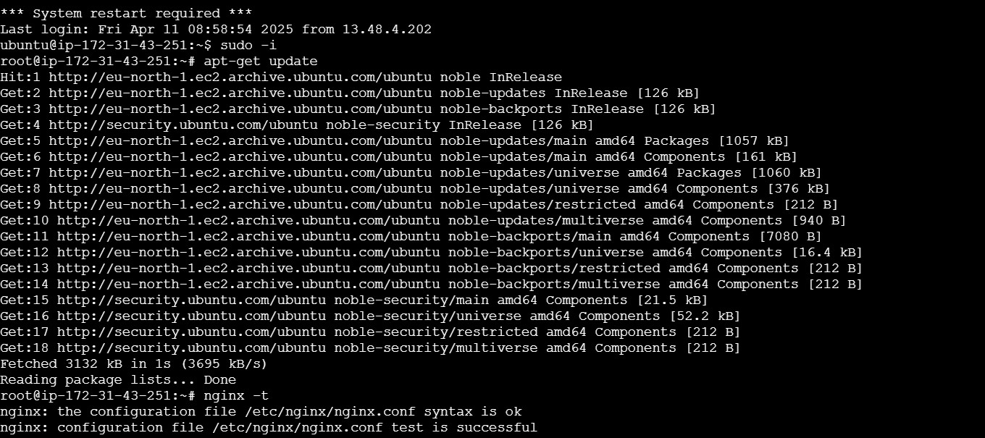

***$apt install nginx and $ Service nginx status***

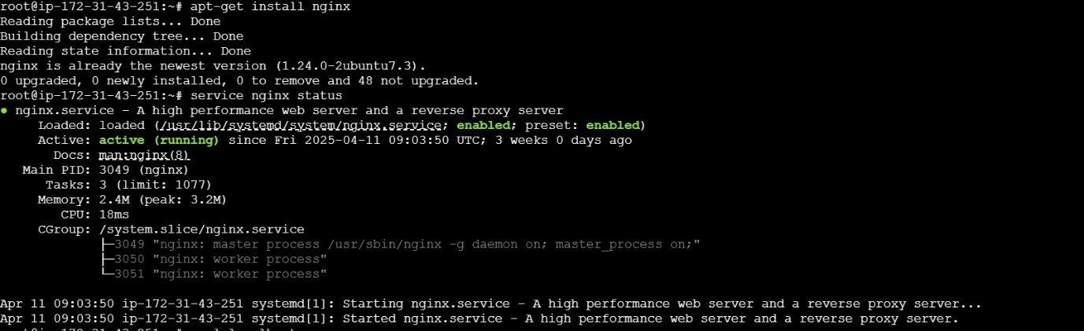

***$curl localhost***

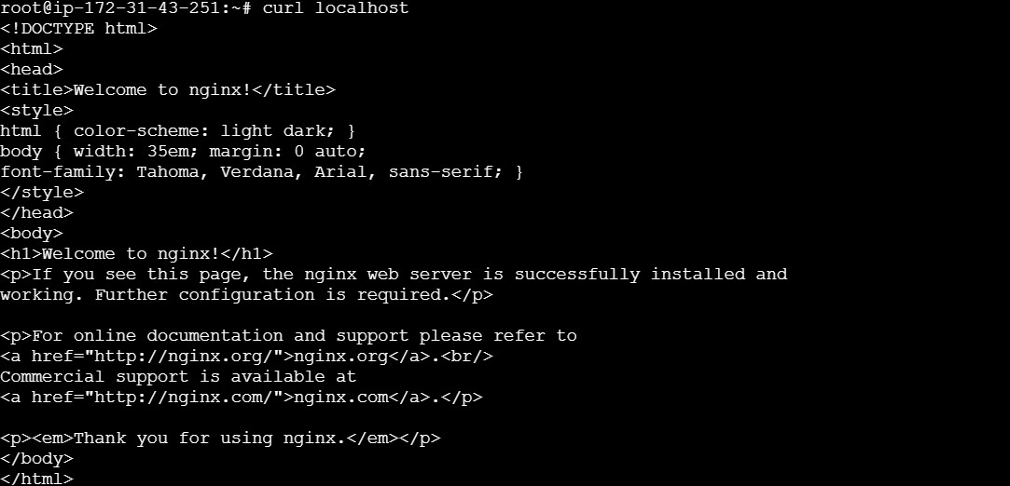

***$ cd/var/www/html/ and $ ls and $cat index.nginx.debian.html***

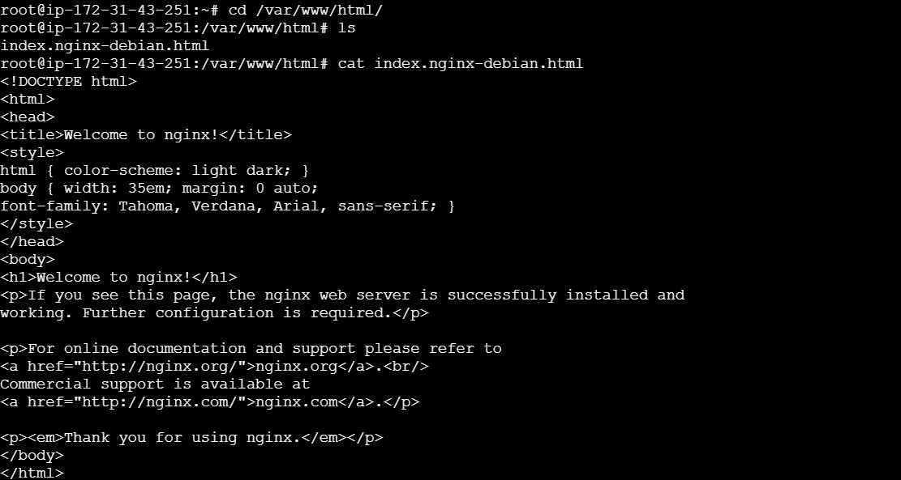

***$echo “Welcome to learn AWS”>index.html and $curl localhost***

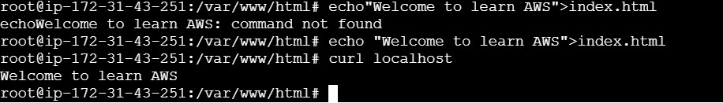

# *Use a Bootstrap Script (User Data)*

* 1. While launching a new EC2 instance, include a **user data script** to automatically install software and configure the environment.

***a.***

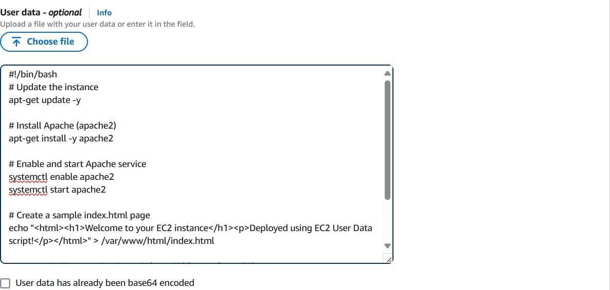

# *Create a Security Group with Inbound and Outbound Rules*

* 1. Create a **custom security group**.
  2. Configure:
     + Inbound rules: Allow SSH (22) from your IP, HTTP (80) from anywhere.
     + Outbound rules: Allow all traffic (default).

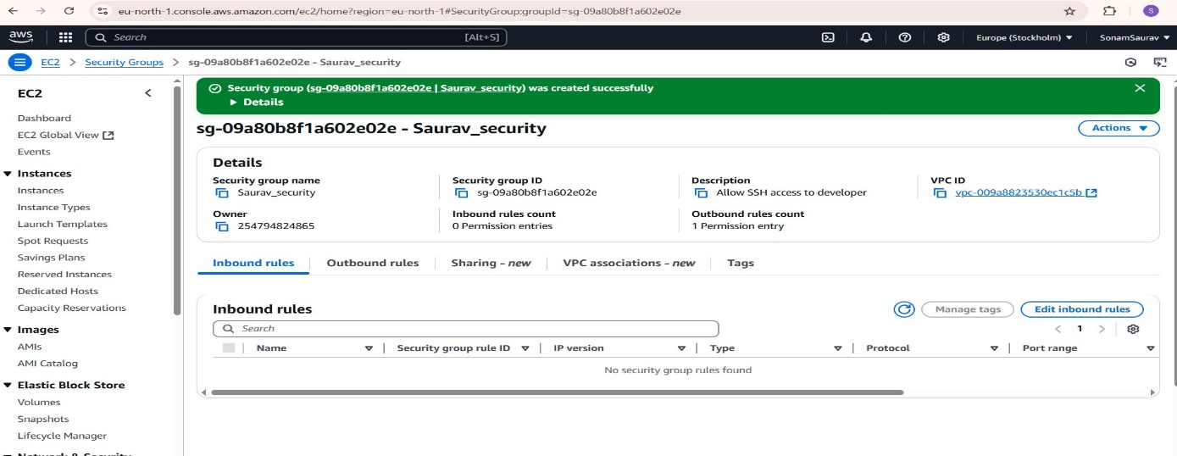

1. ***Inbound_rule***

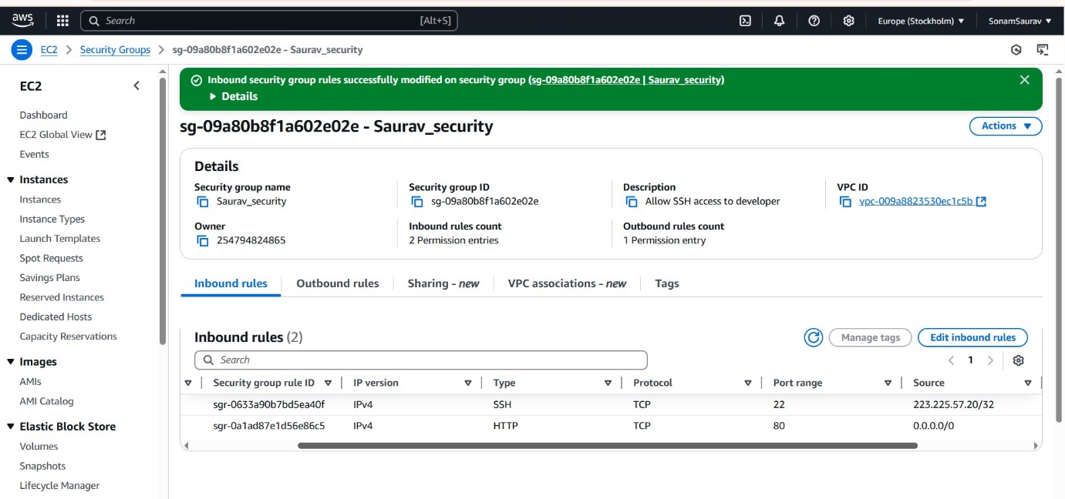

***Outbound_rule***

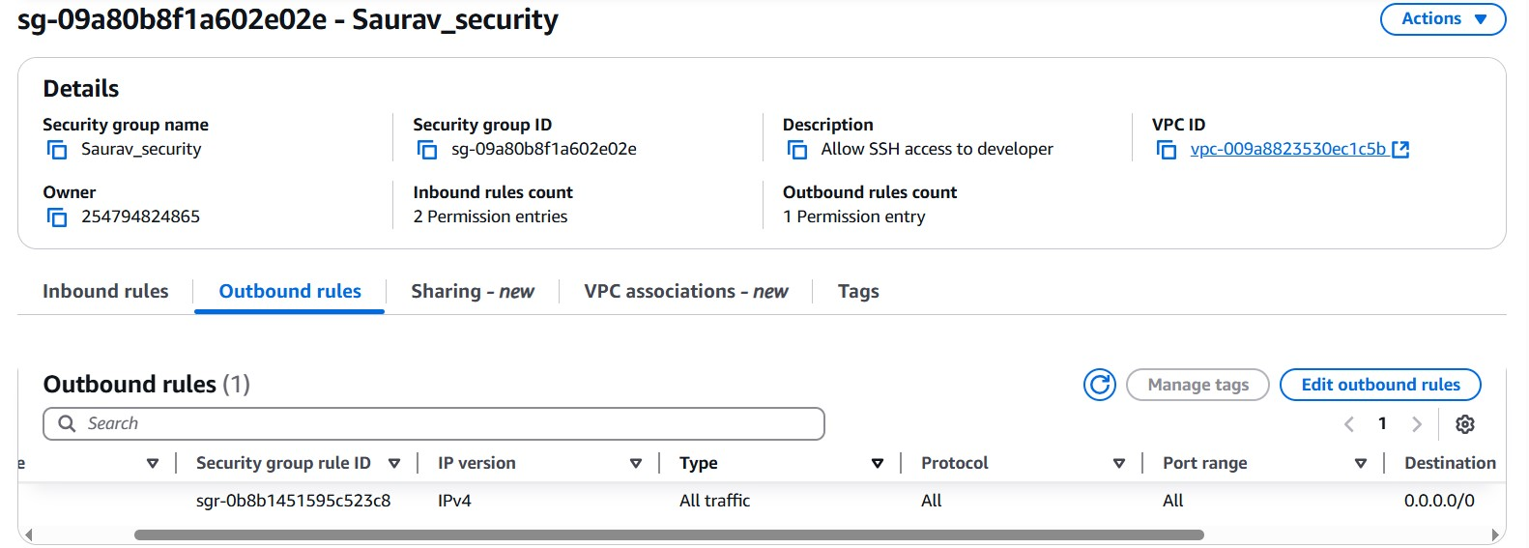

# *Allocate and Attach an Elastic IP (EIP)*

* 1. Allocate a new **Elastic IP address**.
  2. Associate the EIP with your public EC2 instance.

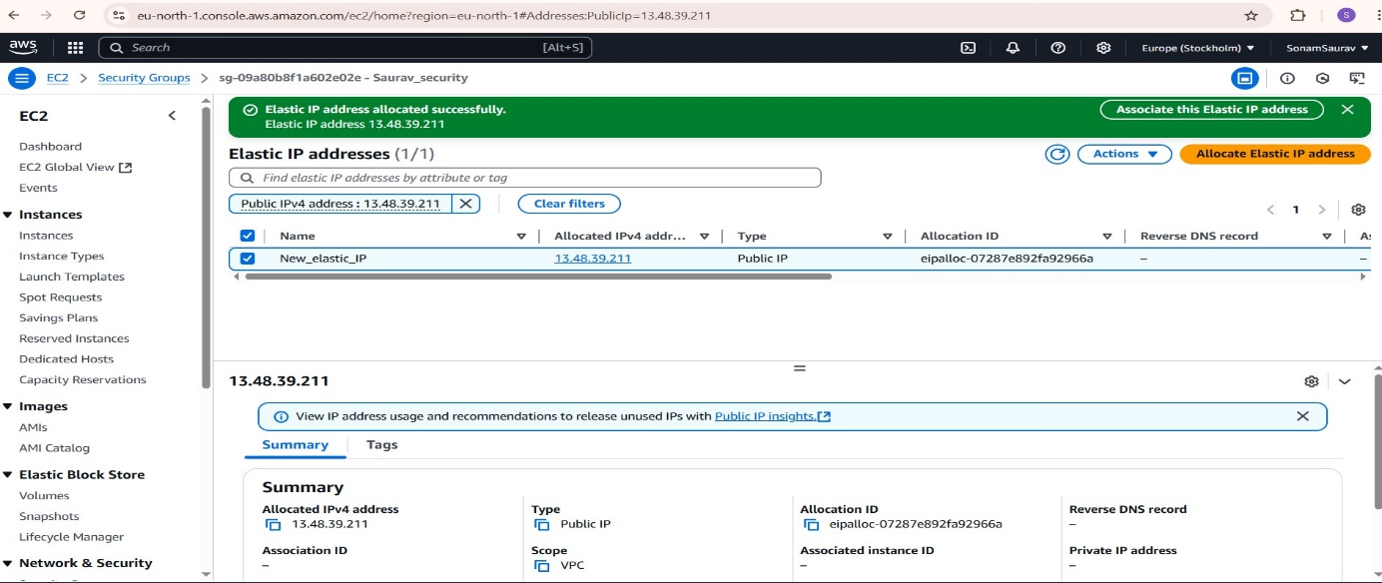

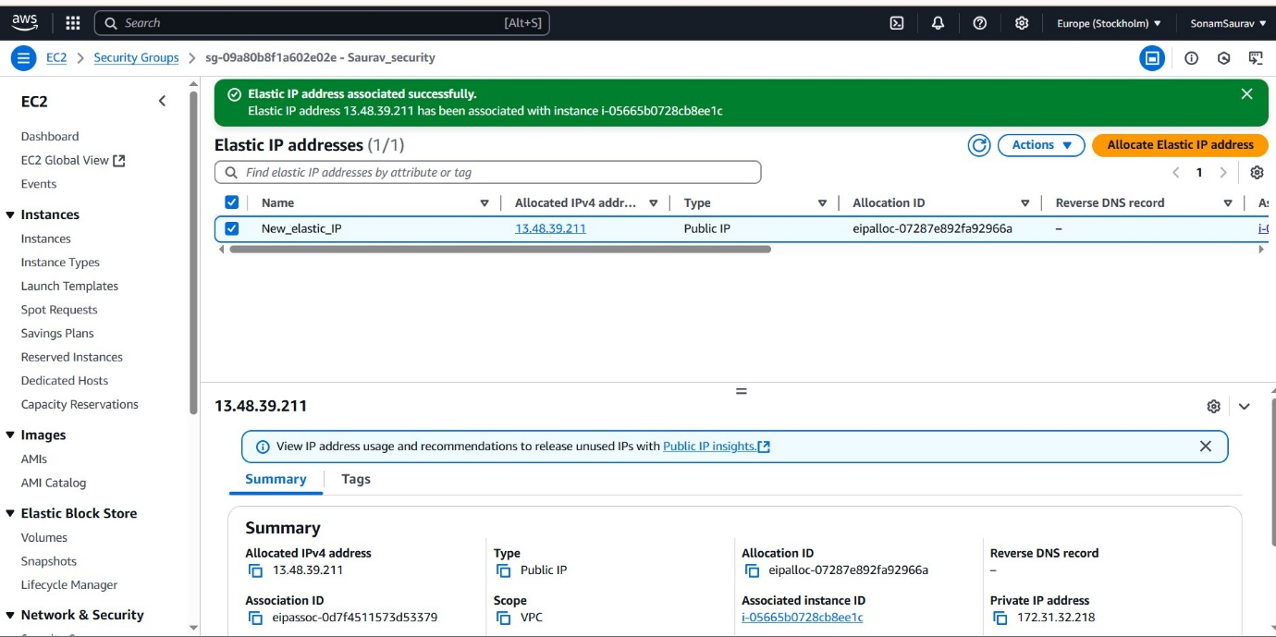

# *Detach and Release Elastic IP*

* 1. Disassociate the EIP from your instance.
  2. Release the EIP from your AWS account to avoid unnecessary charges.

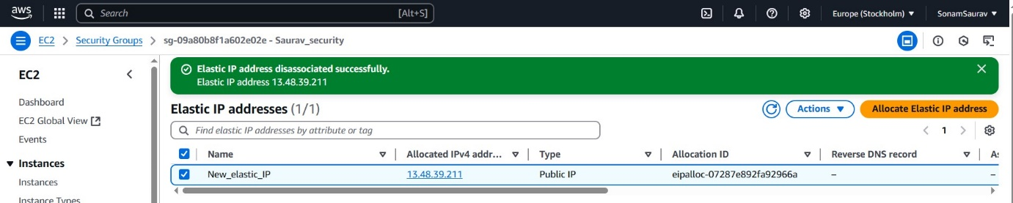

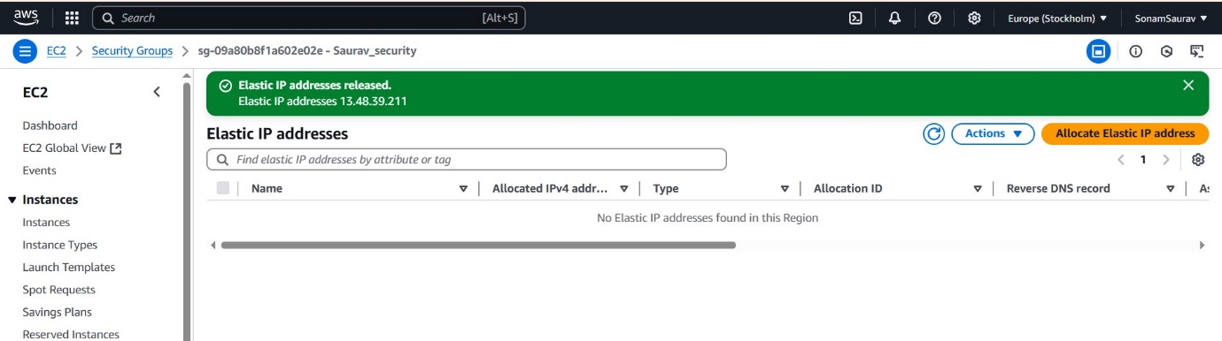

# *Create and Mount an EBS Volume on EC2*

* 1. Create a new **Elastic Block Store (EBS) volume**.

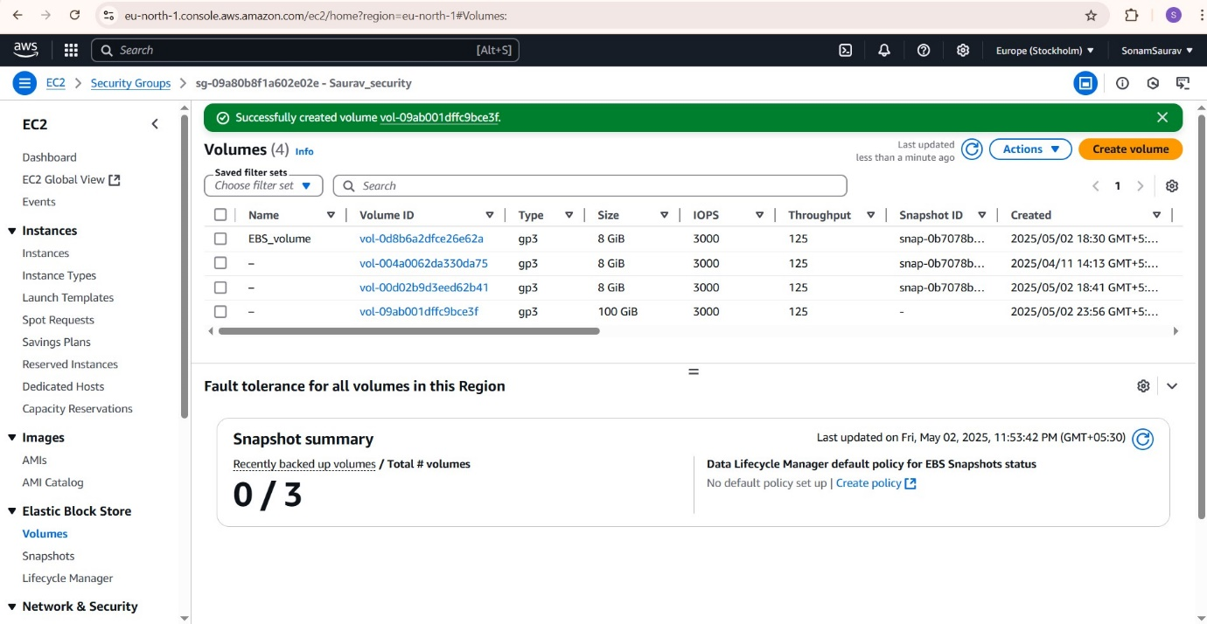

* 1. Attach it to an EC2 instance.

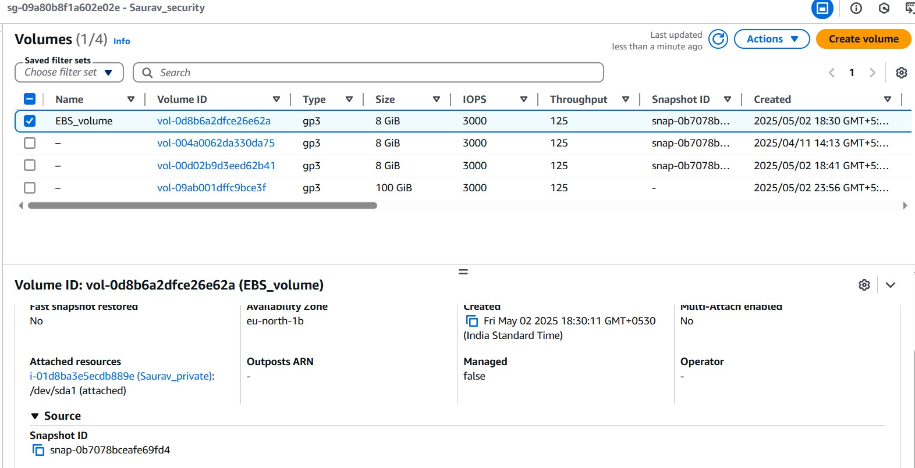

* 1. Format and mount it on the instance:

sudo mkfs -t ext4 /dev/xvdf

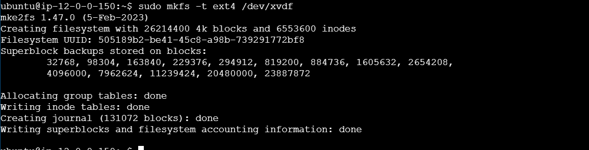

sudo mkdir /data

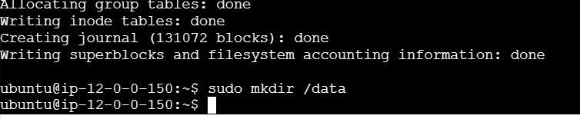

sudo mount /dev/xvdf /data

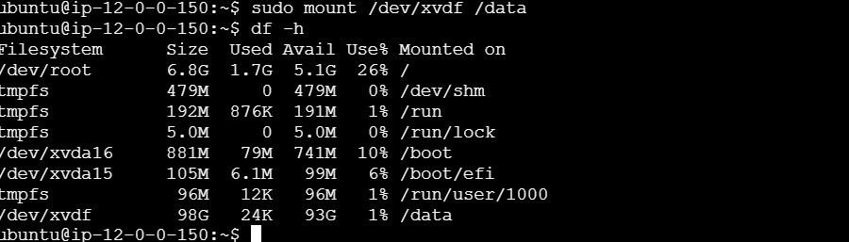

# *Resize EBS Volume and Expand File System*

* 1. Modify the volume size from the AWS Console.

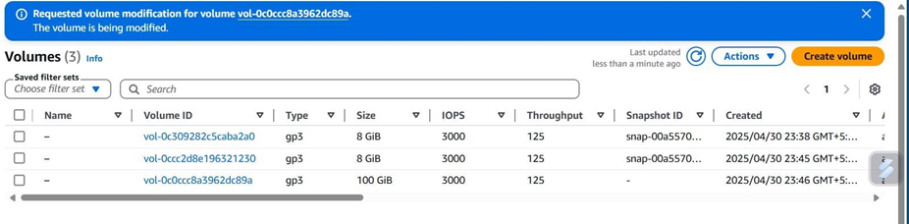

* 1. On the EC2 instance, expand the file system:

sudo growpart /dev/xvdf 1

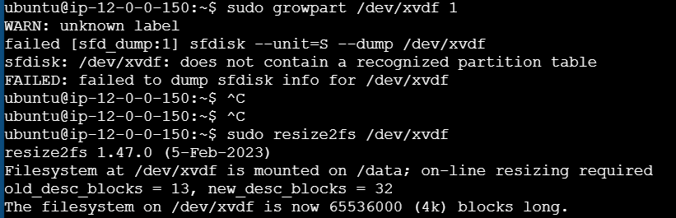

sudo resize2fs /dev/xvdf



# *Attach One EBS Volume to Multiple EC2 Instances*

* 1. Attach the same EBS volume to two instances (in the same Availability Zone).

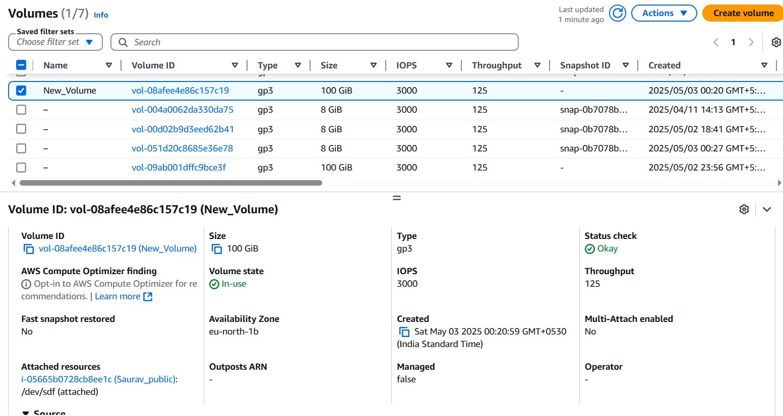

* 1. Mount in **read-only mode** on one instance to avoid conflicts.

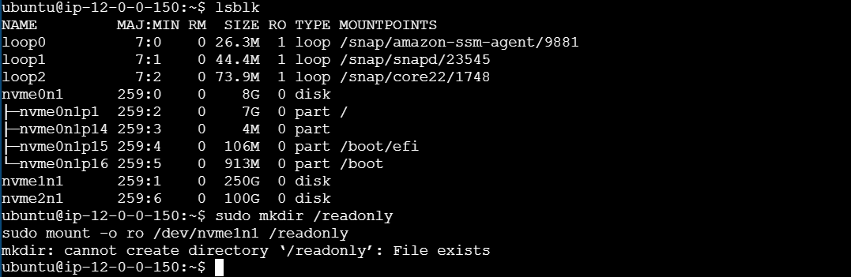

# *Clean Up: Delete EC2 Instances and VPC*

* 1. Terminate all EC2 instances.

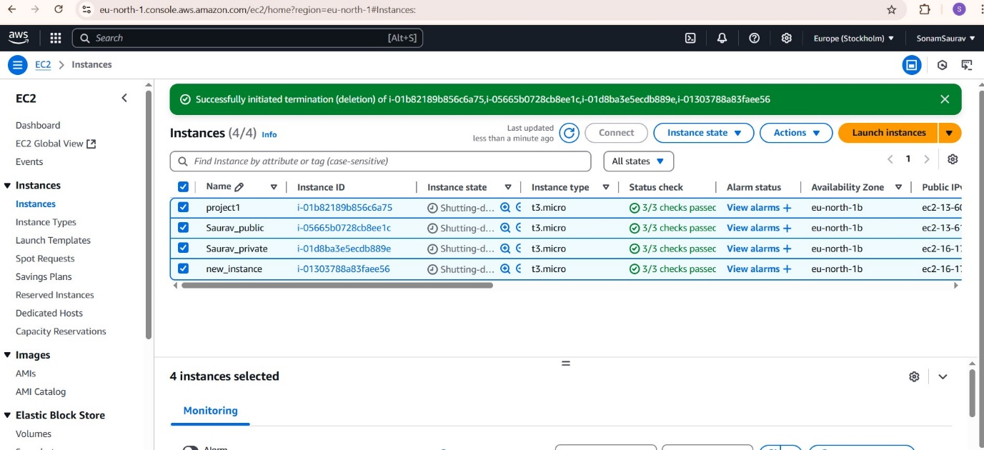

* 1. Detach and delete associated resources: EBS volumes, Elastic IPs, security groups, route tables, and subnets.

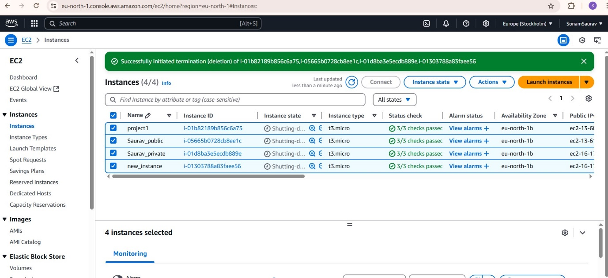

Volumes

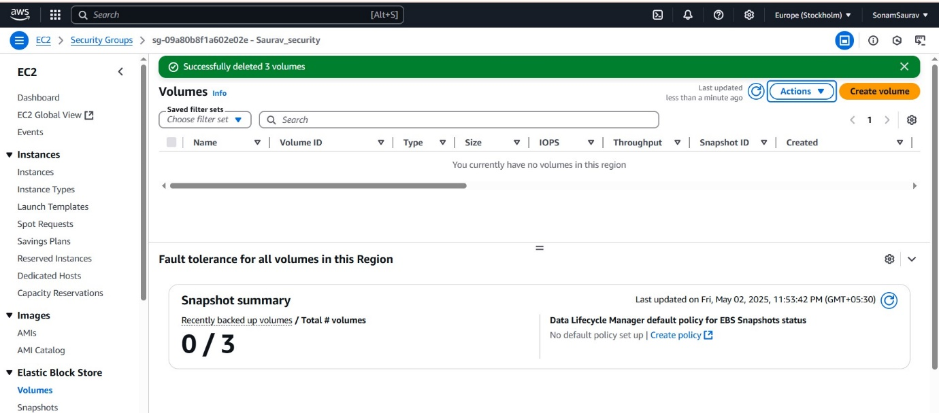

Elastic IP Address

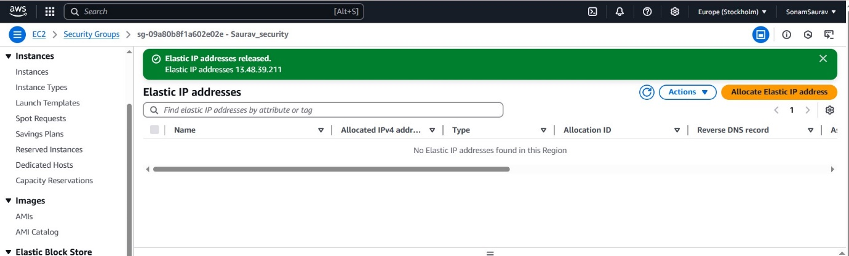

Security Group

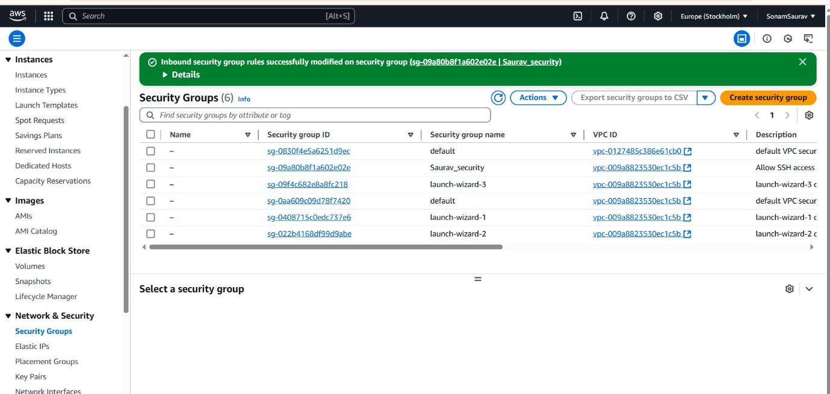

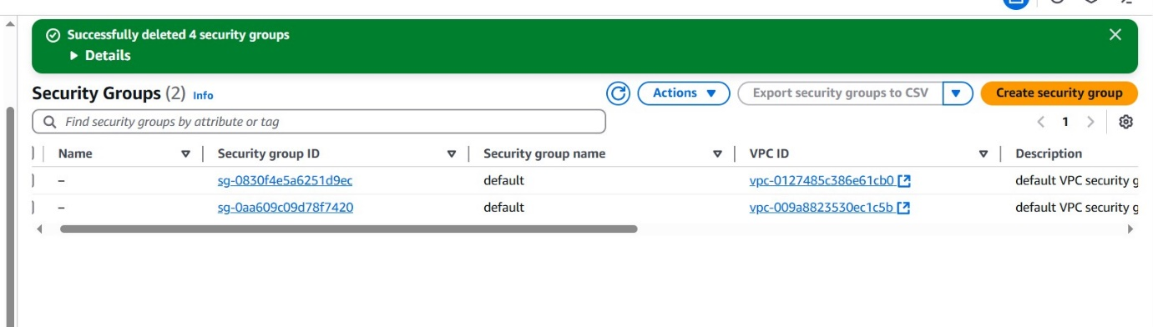

Subnets

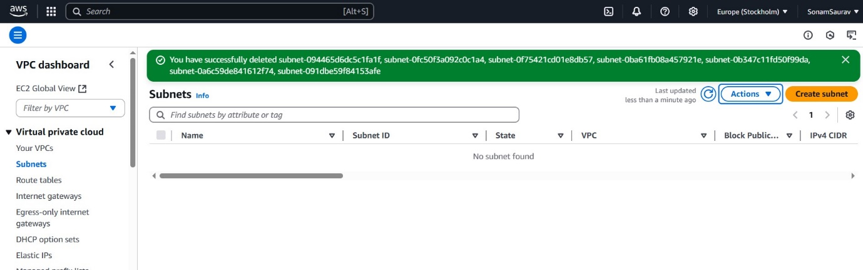

Internet GateWays

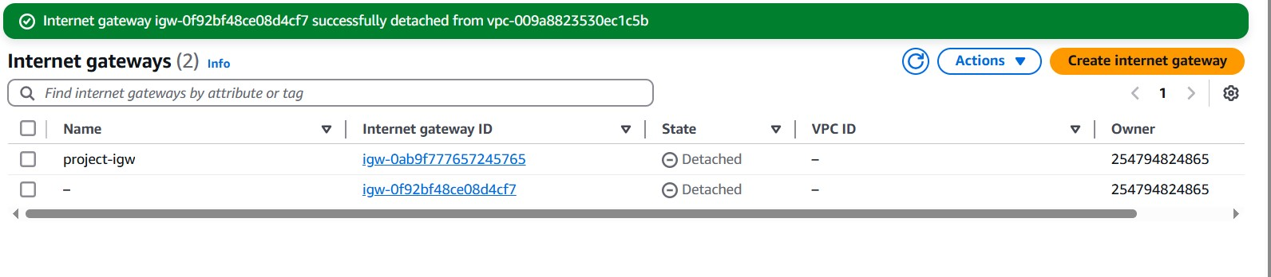

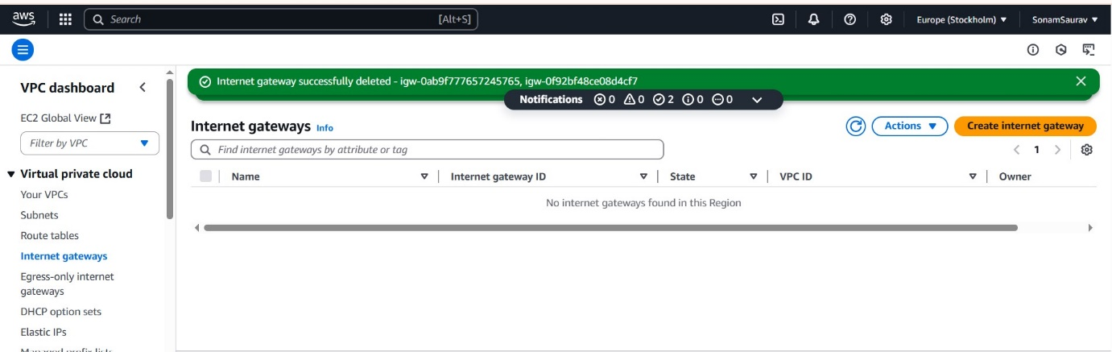

Egress only internet GateWays

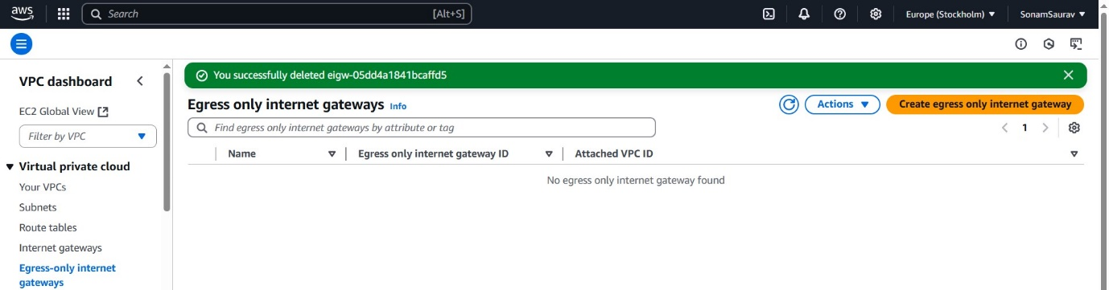

Route Tables

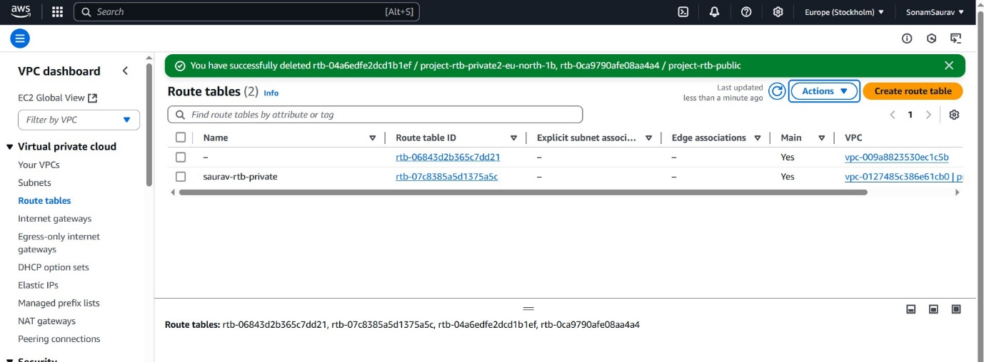

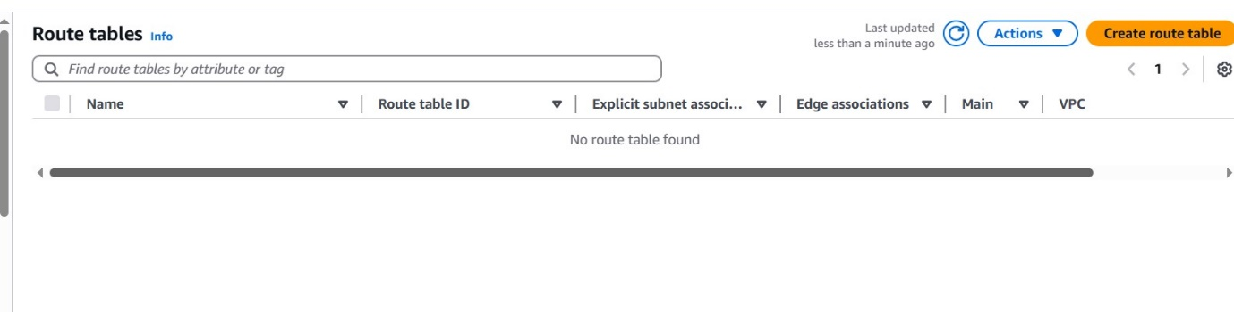

DHCP option sets

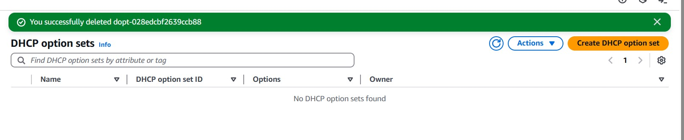

* 1. Finally, delete the VPC.

